

**K.S.R. COLLEGE OF ENGINEERING (AUTONOMOUS)**

**Affiliated to Anna University, Approved by AICTE**

TIRUCHENGODE – 637 215

**DEPARTMENT OF MECHANICAL ENGINEERING**

# LAB MANUAL

***20GE028 - MANUFACTURING PRACTICES LABORATORY***

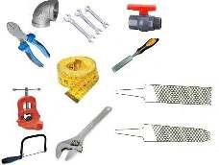

|  |  |
| --- | --- |
| ***NAME*** | T.Prathisha |
| ***ROLL NO*** | 2013077 |
| ***DEPT*** | Computer science and Engineering |

|  |  |  |
| --- | --- | --- |
| **PROGRAMME OUTCOMES (POs) AND PROGRAMME SPECIFIC OUTCOMES (PSOs)** | | |
| **Programme Outcomes (POs)** | |  |
| **PO1** | **Engineering Graduates will be able to:**  **Engineering knowledge:** Apply the knowledge of mathematics, science, engineering fundamentals, and an engineering specialization to the solution of complex engineering problems. |
| **PO2** | **Problem analysis:** Identify, formulate, review research literature, and analyze complex engineering problems reaching substantiated conclusions using first principles of mathematics, natural sciences, and engineering sciences. |
| **PO3** | **Design/development of solutions:** Design solutions for complex engineering problems and design system components or processes that meet the specified needs with appropriate consideration for the public health and safety, and the cultural, societal, and environmental considerations. |
| **PO4** | **Conduct investigations of complex problems:** Use research-based knowledge and research methods including design of experiments, analysis and interpretation of data, and synthesis of the information to provide valid conclusions. |
| **PO5** | **Modern tool usage:** Create, select, and apply appropriate techniques, resource, and modern engineering and IT tools including prediction and modeling to complex engineering activities with an understanding of the limitations. |
| **PO6** | **The engineer and society:** Apply reasoning informed by the contextual knowledge to assess societal, health, safety, legal and cultural issues and the consequent responsibilities relevant to the professional engineering practice. |
| **PO7** | **Environmental and sustainability:** Understand the impact of the professional engineering solutions in societal and environmental contexts, and demonstrate the knowledge of, and need for sustainable development. |
| **PO8** | **Ethics:** Apply ethical principles and commit to professional ethics and responsibilities and norms of the engineering practice. |
| **PO9** | **Individual and team work:** Function effectively as an individual, and as a member or leader diverse teams, and in multidisciplinary settings. |
| **PO10** | **Communication:** Communicate effectively on complex engineering activities with the engineering community and with society at large, such as, being able to comprehend and write effective reports and design documentation, make effective presentations, and give and receive clear instructions. |
| **PO11** | **Project management and finance:** Demonstrate knowledge and understanding of the engineering and management principles and apply these to one’s own work, as a member and leader in a team, to manage projects and in multidisciplinary environments. |
| **PO12** | **Life-long learning:** Recognize the need for, and have the preparation and ability to engage in independent and life-long learning in the broadcast context of technological change. |
| **Programme Specific Outcomes (PSOs)** | |
| **PSO1** | **Research Culture:** Read literature, do research on new mechanical engineering problems and publish the results through patents, journals, conferences and symposium. |
| **PSO2** | **Core Values:** Contribute core universal values and social good to the community. |
|  | |

**K.S.R. COLLEGE OF ENGINEERING (Autonomous) R 2020**

**SEMESTER – I /II**

**20GE028 MANUFACTURING PRACTICES LABORATORY** L T P C

(Common to All Branches) 0 0 3 1

***Prerequisite:*** *No Prerequisites are needed for enrolling into the course.*

## GROUP A (CIVIL & MECHANICAL)

***Objective****:*

* *To study moulding operation and make simple carpentry works.*
* *To make welding of simple structures.*
* *To understand lathe and drilling operations.*

## LIST OF EXPERIMENTS

1. Study of fitting, smithy, plastic moulding, and glass cutting.
2. Prepare a mould using solid/split patterns in Foundry.
3. Make Lap joint / Butt joint / T joint from the given wooden pieces using carpentry tools.
4. Make a Butt joint / Lap joint / Tee joints using arc / gas welding equipment.
5. Perform simple Facing and Turning operation using Centre Lathe.
6. Make holes as per the given dimensions using drilling machine.

## LIST OF EQUIPMENT

1. Fitting tools and its accessories - 15 Sets 2. Smithy tools and Open hearth furnace setup - 2 Sets

1. Foundry tools and its accessories - 5 Sets
2. Carpentry tools and its accessories - 15 Sets
3. Arc Welding equipments and its accessories - 5 Sets
4. Oxy Acetylene welding setup and its accessories - 1 Set
5. Centre Lathe with its accessories - 2 Nos.
6. Pillar type drilling machine - 1 No.

***Course Outcomes: On completion of this course, the students will be able to***

*CO1: Prepare green sand mould for simple patterns and carpentry components with simple joints.*

*CO2: Perform welding practice to join simple structures.*

*CO3: Practice simple operations in lathe and drilling machine.*

## *INDEX*

|  |  |  |  |  |
| --- | --- | --- | --- | --- |
| ***Ex No*** | ***Date*** | ***Title*** | ***Marks*** | ***Sign*** |
| 1 |  | Study of Foundry, Carpentry tools, Welding tools and Basic machine tools. |  |  |
| 2 |  | Prepare a mould using solid pattern in Foundry. |  |  |
| 3 |  | Make T joint from the given wooden pieces using carpentry tools. |  |  |
| 4 |  | Make a bud joint using arc welding equipment |  |  |
| 5 |  | Perform simple facing and turning operation using centre lathe |  |  |
| 6 |  | Make holes as per the given dimensions using drilling machine |  |  |

**Completed Date :**

**Average Marks :**

**Staff Signature :**

|  |
| --- |
| **A LIST OF BASIC SAFETY RULES**     1. When you handle chemicals wear eye protection (chemical splash goggles or full face shield).      1. When you work with furnaces for heat treatment procedures or other thermally activated equipment you should use special gloves to protect your hands.      1. Students should wear durable clothing that covers the arms, legs, torso and feet. (Note:   sandals, shorts, tank tops etc. have no place in the lab. Students inappropriately dressed for lab, at the instructors discretion, be denied access)     1. To protect clothing from chemical damage or other dirt, wear a lab apron or lab coat. Long hair should be tied back to keep it from coming into contact with lab chemicals or flames.      1. In case of injury (cut, burn, fire etc.) notify the instructor immediately.      1. In case of a fire or imminently dangerous situation, notify everyone who may be affected immediately; be sure the lab instructor is also notified.      1. If chemicals splash into someone's eyes act quickly and get them into the eye wash station, do not wait for the instructor.      1. In case of a serious cut, stop blood flow using direct pressure using a clean towel, notify the lab instructor immediately.      1. Eating, drinking and smoking are prohibited in the laboratory at all times.      1. Never work in the laboratory without proper supervision by an instructor.      1. Never carry out unauthorized experiments. Come to the laboratory prepared. If you are unsure about what to do, please ask the instructor.      1. Always remember that HOT metal or ceramic pieces look exactly the same as COLD pieces are careful what you touch.      1. Know the location and operation of:     Fire Alarm Boxes    Exit Doors    Telephones |

|  |
| --- |
| **LABARATORY CLASSES - INSTRUCTIONS TO STUDENTS**     1. Students must attend the lab classes with ID cards and in the prescribed uniform. 2. Boys-shirts tucked in and wearing closed leather shoes. Girls’ students with cut shoes, overcoat, and plait incite the coat. Girls’ students should not wear loose garments. 3. Students must check if the components, instruments and machinery are in working condition before setting up the experiment. 4. Power supply to the experimental set up/ equipment/ machine must be switched on only after the faculty checks and gives approval for doing the experiment. Students must start to the experiment. Students must start doing the experiments only after getting permissions from the faculty. 5. Any damage to any of the equipment/instrument/machine caused due to carelessness, the cost will be fully recovered from the individual (or) group of students. 6. Students may contact the lab in charge immediately for any unexpected incidents and emergency. 7. The apparatus used for the experiments must be cleaned and returned to the technicians, safely without any damage. 8. Make sure, while leaving the lab after the stipulated time, that all the power connections are switched off. 9. EVALUATIONS:   All students should go through the lab manual for the experiment to be carried out for that day and come fully prepared to complete the experiment within the prescribed periods. Student should complete the lab record work within the prescribed periods.  Students must be fully aware of the core competencies to be gained by doing experiment/exercise/programs.  Students should complete the lab record work within the prescribed periods.  The following aspects will be assessed during every exercise, in every lab class and marks will be awarded accordingly:  Preparedness, conducting experiment, observation, calculation, results, record presentation, basic understanding and answering for viva questions. |

Ex No : 1 **Study of Foundry, Carpentry tools, Welding tools and Basic machine tools**

Date :

## FOUNDRY

**Introduction: -**

Foundry practice deals with the process of making casting in moulds, formed in either sand

or other material. This is found to be the cheapest method of metal shaping. The process involves the operations of pattern making, sand preparation, molding, melting of metals, pouring in moulds, cooling, shake out, fettling, heat treatment, finishing, and inspection.

Mould is a cavity in a molding core, formed by a pattern. It is similar in shape and size that

of the actual casting plus some allowance for shrinkage, machining etc., molding is the process of making molds.

**Moulds are classified as: -**

* Temporary moulds
* Permanent moulds

Temporary mould are made of sand and other binding materials and may be produced either through hand molding (or) machine molding.

Permanent moulds are made of ferrous materials and alloys i.e., cast iron, steel etc.,

**Molding Sand: -**

Sand is the principle material used in foundry. The principle ingredients of molding sands are

* Silicon sand
* Clay
* Sand

Clay imparts the necessary bonding strength to the molding sand, moisture when added to correct preparation provides the bonding action to the clay sand can withstand high temperature and doesn’t react with molten metal.

Natural molding sand is either available in river beds are dug from pits. It possesses and appreciable amount of clay and are used as received with the addition of water. Synthetic sands are prepared by adding clay. Water and other materials to silica sand so that the desirable strength and banding properties are achieved.

Most of molding is done with green sand i.e.; sand containing 6 to 8%, moisture and 10% clay content to give it sufficient bond. Green sand moulds are used for pouring the molten metal

– immediately after preparing the moulds. Green sand moulds are cheaper and take less time to prepare. These are used for small and medium size casting.

Parting sand, which is clay tree, fence grained silica sand, is used to keep the green sand from sticking to the pattern and also to prevent the cope and drug from cleaning. Core sand is used for making cores. This is silica missed with core oil and other oddities.

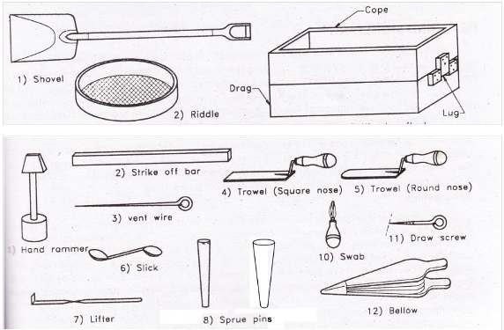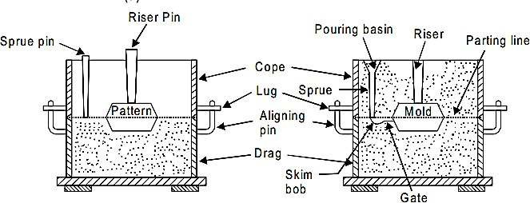

**Pattern; -**

A pattern is the replica of the desired coasting, which when packed in a suitable materials produces a cavity called mould. This cavity when filled with molten metals, produces their desired coasting of the solidification.

**Types of pattern; -**

Wood are metal patterns are used in foundry practice, single piece, split loose piece and cored patterns are some of the common types.

**Tools and equipment; -**

The tools are equipment needed for molding are; -

**Molding board: -**

It is wooden board with smooth surfaces. It supports the flasks and the pattern, while the mould is being made.

**Molding Flask: -**

It is a base, made of wood or metal, open at both ends. The sand is rammed in after placing the pattern to produce a mould it is made of 2 parts; cope is the top half of the flask, having guides for the aligning paints to enter. Drag is the bottom half of the flask having aligning pins.

**Shovel: -**

It is used for mixing and tempering molding sand and for transferring the sand in to the flask. It is made of steel blade with a wooden handle.

**Rammer: -**

It is used for pocking or ramming the sand, around the pattern one of its ends called the peen end, is wedge shaped and is used for packing sand in spaces, pockets and corners in the early stages of ramming. The other end called the But – end has a surface and is used for computing the sand towards the end of molding.

**Strike of edge / strike of bar: -**

It is a piece of metal or wood with straight edge. It is used remove the excess sand from the mould after ramming to provide a level surface.

**Spruce pin: -**

It is tapered wooden pin used to make a hole in the cope sand through which the molten metal is poured into the mould.

**Riser pin: -**

It is tapered wooden pin used to make a hole in the cope sand over the mould cavity for the molten metal to rise and feed the casting to compassable the shrinkage that take place during solidification.

**Trowel: -**

It is used to smoothen the surface of the mould. It may also be used for reproducing the damaged portion of the mould. A trowel is made in many different styles and sizes each one recallable for a particular hole.

### CARPENTRY

Carpentry is the process of working with wood for applications such as floor works, roofs and partitions in a building.

**Carpentry Tool:**

The following are the tools used in wood working operations

#### (a) Marking and Measuring Tools

To produce parts to exact size we need to do marking first. To transfer dimensions onto work; the following are the marking and measuring tools that are generally used in carpentry

* **Steel Rule**

It is an important tool for linear measurement and can also be used as a marking tool.

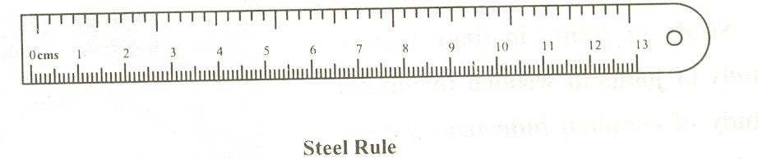

* **Marking Gauge**

Marking gauge is a tool used to mark lines parallel to the edge of a wooden piece. It consists of a square wooden stem with a sliding wooden stem with a sliding wooden stock (head) on it. On the stem is fitted with a marking pin, made of steel. The stock is set at desired distance from the marking point and fixed in position by a screw. It must be ensured that marking pin projects through the stem 3mm and the end is sharp enough to make a very fine line.

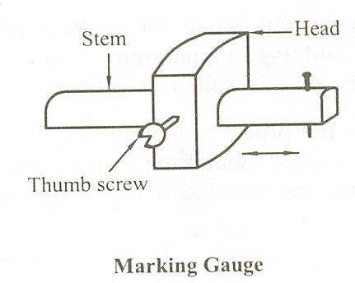

* **Try Square**

It is used for making and testing the straightness and squareness (perpendicularity) of planed surfaces. It consists of a steel blade, fitted in a cast iron stock. It is also used for checking the planed surfaces for flatness. Its size varies from 150 to 300 mm, according to the length of the blade.

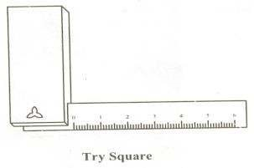

* **Compass and Divider**

These are used for marking arcs and circles on the planed surfaces of the wood.

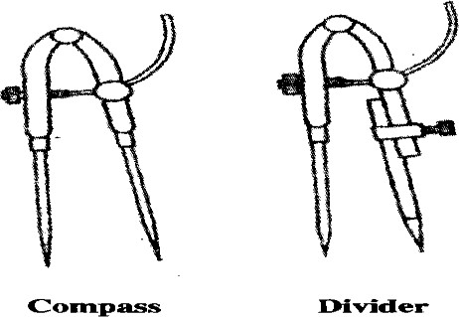

* **Scriber or Marking Knife**

It is used for marking on timber. It is made of steel, having one end pointed and the other end formed into a sharp cutting edge.



#### Holding Tools

* **Bench Vice**

The carpenter's bench vice, used as a work holding device in a carpenter shop. Its one jaw is fixed the side of the table while the other is movable by means of the screw and a handle. The jaws are lined with hard wooden faces.

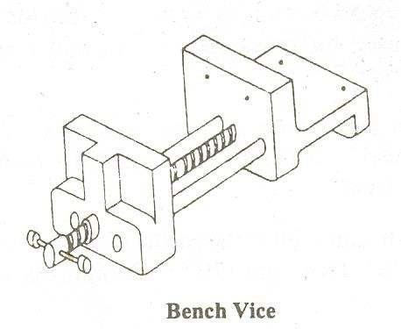

* **C Clamp**

A C clamp is made up of malleable iron. The opening capacity varies from 50 to 350mm. It can be used for clamping small work. The swivel shoe allows fixing angled work.

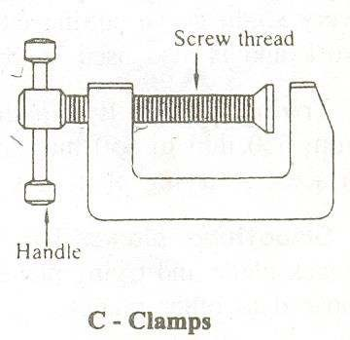

#### (b) Planing Tools

Planing is the operation carried out on wood to produce flat surfaces. A plane is a hand tool used for this purpose. The cutting blade of a plane is fitted in a wooden or metallic block, at an angle. This cutting blade used in a plane is similar to a chisel. Different types of planes used for different purposes are shown here below.

• **Jack Plane**

It is the most commonly used general purpose plane. It is about 30-40 cm long. The cutting blade has a cutting edge of slight curvature for quick removal of material on rough work and is also used in oblique planning, It is used for making a rebate. A rebate is a recess along the edge of a piece of wood, which is generally used for positioning glass in frames and doors.

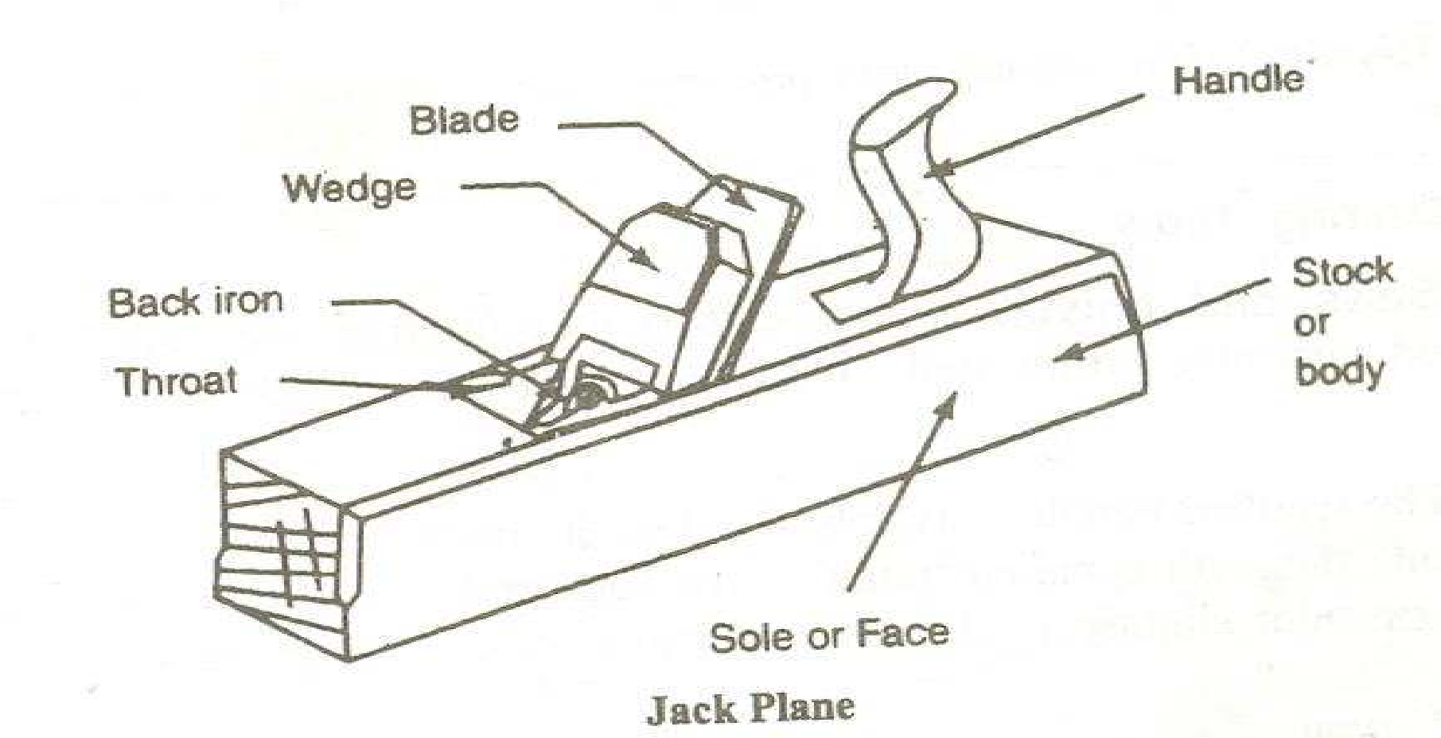

#### (c) Cutting Tools

• **Saws**

A saw is used to cut wood into pieces. A saw is specified by length of its toothed edge. The different types of saws, designed to suit different purposes are shown below.Cross-cut or Hand Saw

It is used to cut across the grains of the stock. The teeth are so set that the saw kerfs will be wider than the blade thickness for moving free11 during the cut, without sticking.

* **Rip Saw**

It is used for cutting the stock along the grains. The cutting edge of this saw makes a steeper angle, i.c. about 60" (see figure), where as that of cross cut saw makes an angle of 45" with the surface of the stock.

* **Tenon Saw**

It is used to cut the stock either along or cross the grains. It is used for cutting tenons and in fine work. However, it is used for small and thin cuts. The blade of this saw is very thin and hence it is stiffened with a thick back steel strip. Hence, this is sometimes called back-saw also. (In fact in back saw, the teeth are shaped like those of cross-cut saw).

* **Compass Saw**

It has a narrow, longer and stronger tapering blade, which is used for heavy works (see figure). It is mostly used for radius cutting. The blade of this saw is fitted with **an** open type wooden handle.

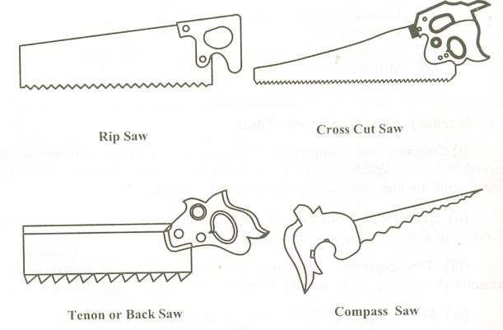

* **Chisels**

Chisels are used for cutting and shaping the wood. Chisels used for wood working are made in various blade widths, ranging from **3** to 50 mm. They are also made in different blade lengths. Most of the chisels used for wood working are made into tang type, having steel shank which fits inside the handle as shown in the figure. These are made of forged steel or tool steel blades.

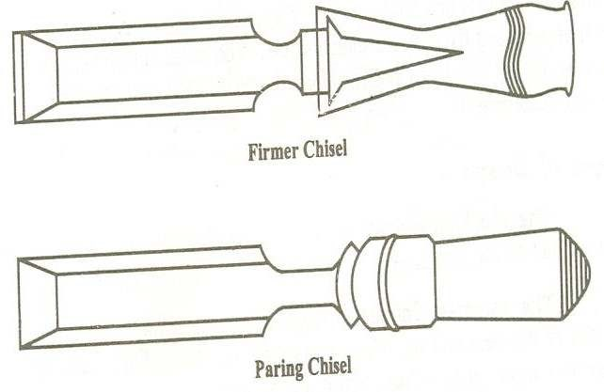

* **Firmer Chisel**

The word 'firmer' means 'stronger' and hence firmer chisel is stronger than other chisels. It is a general purpose chisel and is used either by hand pressure or by a mallet. The blade of a firmer chisel is flat, as shown in Figure

* **Paring Chisel**

Paring Chisel has a thinner blade and used for light work. This chisel is used for saving or paring plane surfaces. The blade has either square or beveled edges.

#### (d) Drilling And Boring Tools

* **Carpenter's Brace**

This is used for rotating auger bits, twist drills, etc., to produce holes in wood as shown in the Figure 1.10. Some braces have ratchet device. With this, holes may be made in a comer where complete revolution of the handle cannot be made. The size of a brace is determined by its sweep.

* **Gimlet**

It has cutting edges like a twist drill as shown in the Figure I .12. It is used to drill holes of large diameter with the hand pressure.

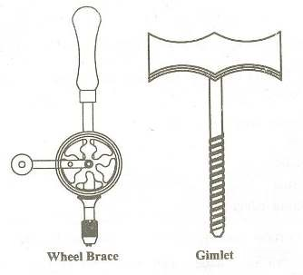

#### (e) Miscellaneous Tools

• **Mallet**

A mallet made up of wood or rubber is like a hammer used to drive the chisel with considerable force to be applied, which may be the case in making deep rough cuts (Figure 1.13). SteeVIron hammer should not be used for the purpose, as it may damage the chisel handle. Further, it is advisable to apply a seiies of light taps with the mallet rather than a heavy single blow.

* **Pincer**

It is usually made up of two forged steel arms hinged and is used to pull-out small nails from wood. The inner faces of the pincer jaws are beveled and the other faces are plain. The end of one arm has a ball and the other has a claw. The beveled jaws and the claw are used for pulling out small nails, pins and screws from the wood.

* **Claw Hammer**

It has **a** striking flat face at one end and the claw at the other, as shown in the Figures. The face is used to drive nails into wood and for other striking purposes and the claw extracting relatively large nails out of the wood. It is usually made up of cast iron.

* **Screw Driver**

This is used for driving a screw (unscrew) into (from) the wood. In fact the screw driver of a carpenter is different from the other common types, as given in the Figure**.** The length of the screw driver is determined by the length of blade as the length of the blade increase, the width and thickness of the tip also increases.

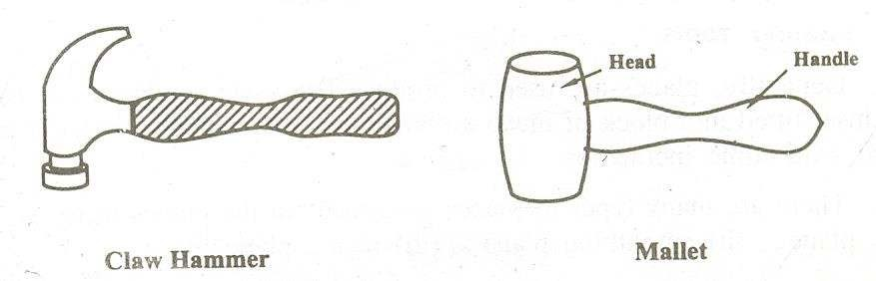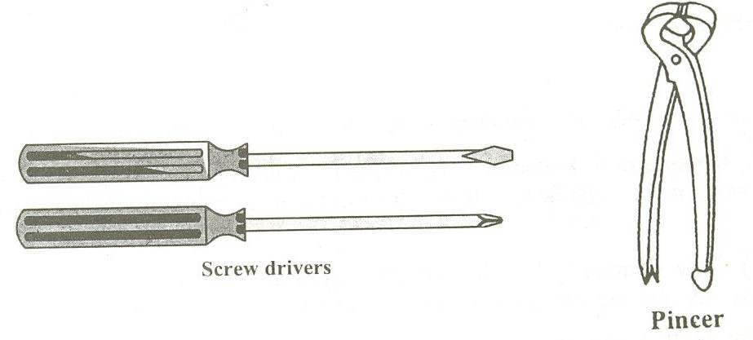

### Welding

Welding is a metal joining process wherein localized coalescence is produced either by heating the metal to a suitable temperature, with or without the use of filler metal, with or without application of pressure. The filler material has similar composition and melting point temperature as that of the base metal. It is used to fill gap between the joint surfaces.

#### *Types of welding*

1. Forge welding
2. Resistance
3. welding
4. Fusion welding
5. Gas welding
6. Electric arc welding
7. Thermit welding
8. Oxy-acetylene welding

#### *Arc welding*

In arc welding process, the source of heat is electricity. In arc welding process, coalescence is produced by heating the work piece with an electric is stuck between an electrode and the work piece. Welding may be carried out in air or in an inert atmosphere. Filler material may or may not be used. The temperature of the arc is of the order of 3600oC.

#### *Principle of Arc welding*

The heat required for joining the metals is obtained from an electric arc. The electric motor generator or transformer sets are used to supply high electric current and the electrodes are used to produce the necessary arc. The electrode serves as the filler rod and arc melts the surfaces so that the metals to be joined are fused together. The transformer type welding machine produces A.C current. It takes power directly from power supply to produce high current and low voltage to the welding. It is least expensive.

Motor generator type welding machine produces DC current to welding machine. This current is having straight or reversed polarity. The polarity selected for welding depends on the electrode arc used in the welding.

#### *Welding Tools and Cleaning Accessories*

1. **Electrodes**

Filler rods used in the arc welding is known as electrodes. The electrodes are made of metallic wire called core wire. It is coated uniformly with a protective coating called flux while fluxing an electrode about 20mm of length is left at one end for holding it using electrode holder. It is used to transmit full current to the front end of the electrode coating.

The size of the diameter of the core wire will depend on the amount of weld metal to be deposited and on the type of joint.

1. **Electrode Holder** 
   * It is a device used for mechanically holding the electrode and conducting current to it.
   * It should be tight, to minimize fatigue incurred by the welder.

1. **Welding cables** 
   * + Two cables are needed for welding purpose. One is used to connect power source to electrode, another cable is connected to ground.
     + The cables are well isolated with rubber.

#### Weld Cleaning Accessories

The following tools are used in welding work shop to clean the weld after the welding practice

**(a) Chipping Hammer**

A chipping hammer is a chisel shaped one and it is used to remove the slag from the weld bead.

1. **Wire Brush**

It is made of stiff steel wire, embedded in wood, removes small particles of slag from the weld bead after the chipping hammer is used.

1. **Hand Shield**

It is a protective device used in arc welding. A hand shield is held in the hand of the welder and fitted with a suitable fitter lens.

1. **Helmet**

It is used for shielding and protecting the face and neck of the welder and it is fitted with a suitable fitter lens.

1. **Tongs**

Tongs are used to handle the hot metal welding job while cleaning, they are also used to hold for hammering.

1. **Goggles**

It is used to protect the eyes while chipping the slag. They are fitted with a plain glass to see the area to be protected.

1. **Hand Gloves**

These are used to protect the handle from electrical shock, arc radiation and hot spatters.

##### Points To Be Considered Before Welding

* Check whether the welding cables are connected into proper power sources.
* Set the welding current as per the diameter of the electrode to be used.
* Before going for welding, the material must be prepared well.
* Hold the electrode about 25mm above the job-piece at one end, perpendicular to the surface and then, bring the welding screen in front of your eyes.
* Strike the arc by dragging the electrode quickly and softly across the welding job.
* Select the electrode as per true thickness of metal to be welded.
* Withdraw the electrode 6mm from the surface of the welding material far from and then lower it to 4mm distance to the material.

##### Applications of arc welding

* The process finds the applications in
* Air receiver tank, boiler structural’s and pressure vessels fabrications.
* Ship building.
* Building and bridge constructions.

### Basic Machining

#### *I. Lathe*

A Lathe is an important and oldest known machine tool in any workshop. The job to be machined is held and rotated in a chuck, face plate, catch plate, between entres etc. A suitable cutting tool is advanced against rotating job. Since the cutting tool material is harder than the work piece, the metal is easily removed from the job in the form of chip. Cutting tool used is a single point cutting tool.

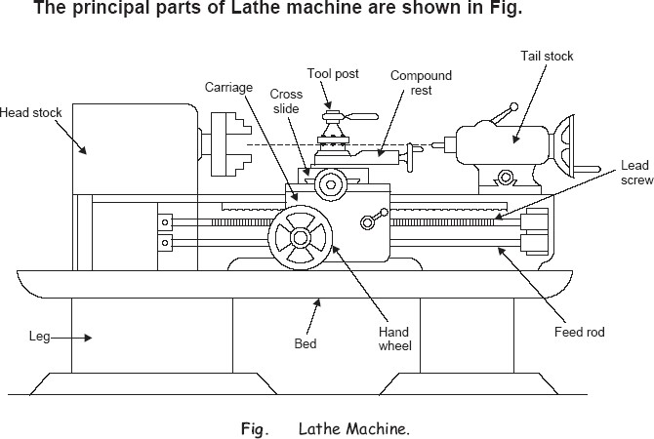

1. **Bed**: The bed is a heavy, rugged casting in which are mounted the working parts of the lathe. It carries the headstock and tail stock for supporting the work piece and provides a base for the movement of carriage assembly which carries the tool.
2. **Legs**: The legs carry the entire load of machine and are firmly secured to floor by foundation bolts.
3. **Headstock**: The headstock is clamped on the left hand side of the bed and it serves as housing for the driving pulleys, back gears, headstock spindle, live centre and the feed reverse gear. The headstock spindle is a hollow cylindrical shaft that provides a drive from the motor to work holding devices.
4. **Gear Box**: The quick-change gear-box is placed below the headstock and contains a number of different sized gears.
5. **Carriage**: The carriage is located between the headstock and tailstock and serves the purpose of supporting, guiding and feeding the tool against the job during operation. The main parts of carriage are:
6. **The saddle** is an H-shaped casting mounted on the top of lathe ways. It provides support to cross-slide, compound rest and tool post.
7. **The cross slide** is mounted on the top of saddle, and it provides a mounted or automatic cross movement for the cutting tool.
8. **The compound rest** is fitted on the top of cross slide and is used to support the tool post and the cutting tool.
9. **The tool post** is mounted on the compound rest, and it rigidly clamps the cutting tool or tool holder at the proper height relative to the work centre line.
10. **The apron** is fastened to the saddle and it houses the gears, clutches and levers required to move the carriage or cross slide. The engagement of split nut lever and the automatic feed lever at the same time is prevented she carriage along the lathe bed.
11. **Tailstock**: The tailstock is a movable casting located opposite the headstock on the ways of the bed. The tailstock can slide along the bed to accommodate different lengths of work piece between the centers. A tailstock clamp is provided to lock the tailstock at any desired position. The tailstock spindle has an internal taper to hold the dead centre and the tapered shank tools such as reamers and drills.

#### Lathe Operations

The engine lathe is an accurate and versatile machine on which many operations can be performed. These operations are

|  |  |
| --- | --- |
| 1. Plain Turning and Step Turning | 2. Facing |
| 3. Parting | 4. Drilling |
| 5. Reaming | 6. Boring |
| 7. Knurling | 8. Grooving |
| 9. Threading | 10. Forming |

#### Drilling Machine

* Drilling is the operation of producing circular hole in the work-piece by using a rotating cutter called DRILL.
* The machine used for drilling is called drilling machine.
* The drilling operation can also be accomplished in lathe, in which the drill is held in tailstock and the work is held by the chuck.
* The most common drill used is the twist drill.
* It is the simplest and accurate machine used in production shop.
* The work piece is held stationary ie. Clamped in position and the drill rotates to make a hole.

##### Types

1. **Based on construction**

Portable

Sensitive Radial up-right

Gang

Multi-spindle

1. **Based on Feed**

Hand driven

Power driven

##### Components of Drilling Machine

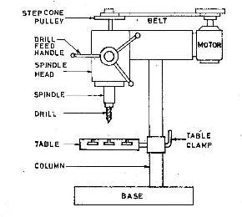

***Spindle***

The spindle holds the drill or cutting tools and revolves in a fixed position in a sleeve

##### Sleeve

The sleeve or quill assembly does not revolve but may slide in its bearing in a direction parallel to its axis. When the sleeve carrying the spindle with a cutting tool is lowered, the cutting tool is fed into the work: and when it’s moved upward, the cutting tool is withdrawn from the work. Feed pressure applied to the sleeve by hand or power causes the revolving drill to cut its way into the work a fraction of an mm per revolution.

##### Column

The column is cylindrical in shape and built rugged and solid. The column supports the head and the sleeve or quill assembly.

##### Head

The head of the drilling machine is composed of the sleeve, a spindle, an electric motor and feed mechanism. The head is bolted to the column.

##### Work table

The worktable is supported on an arm mounted to the column. The worktable can be adjusted vertically to accommodate different heights of work or it can be swung completely out of the way. It may be tilted up to 90 degree in either direction, to allow long pieces to be end or angle drilled.

##### Base

The base of the drilling machine supports the entire machine and when bolted to the floor, provides for vibration-free operation and best machining accuracy. The top of the base is similar to the worktable and may be equipped with t- slot for mounting work too larger for the table.

##### Hand Feed

The hand- feed drilling machines are the simplest and most common type of drilling machines in use today. These are light duty machine that are operated by the operator, using a feed handled, so that the operator is able to “feel” the action of the cutting tool as it cuts through the work piece. These drilling machines can be bench or floor mounted.

##### Power feed

The power feed drilling machine are usually larger and heavier than the hand feed ones they are equipped with the ability to feed the cutting tool in to the work automatically, at preset depth of cut per revolution of the spindle these machines are used in maintenance for medium duty work or the work that uses large drills that require power feed larger work pieces are usually clamped directly to the table or base using t –bolts and clamps by a small work places are held in a vise. A depth –stop mechanism is located on the head, near the spindle, to aid in drilling to a precise depth.

**Drill Materials**

***The two most common types ar***

1.

HSS drill -

L

2.

Carbide- tipped drills -

***Other types are***

Solid Carbide drill, TiN coa

point drill.

**Drill fixed to the spindle**

**Nomenclature of twist drill**

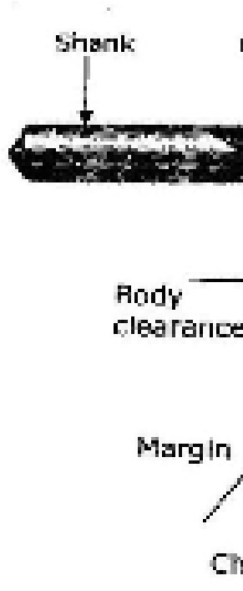

***e***

ow

cost

high production and in CNC machines

ted drills, carbide coated masonry drills, p

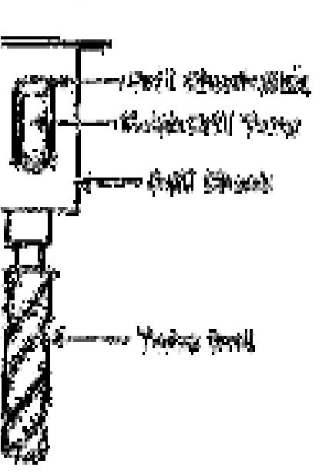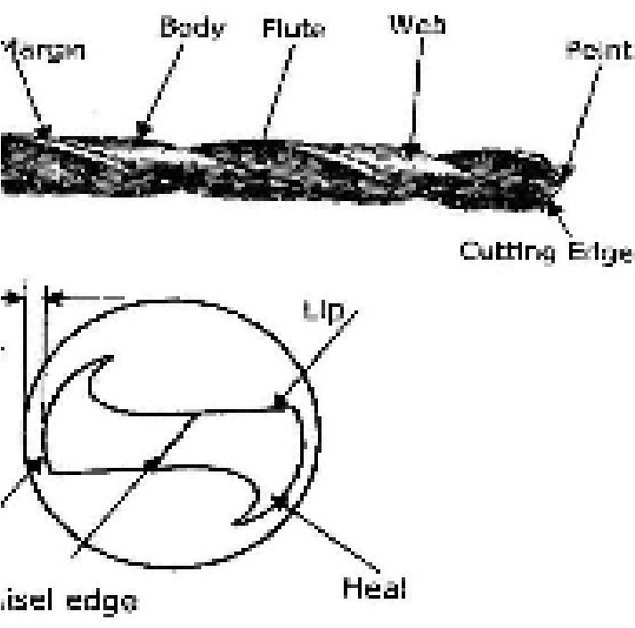

arabolic drills, split

##### Tool holding devices

The following figure shows the different work holding and drill drift device. The different methods used for holding drill in a drill spindle are • By directly fitting in the spindle hole.

* By using drill sleeve
* By using drill socket
* By using drill chuck

##### Drilling operations

Operations that can be performed in a drilling machine are o Drilling o Reaming o Boring o Counter boring o Countersinking o Tapping

##### Work Holding Devices Machine Table Vice

The machine vice is equipped with jaws which clamps the work piece. The vice can be bolted to the drilling table or the tail can be swung around swung around. Fig. 13 shows the standard and swivel vice.

The swivel vice is a machine wise that can be swivel through 360° on a horizontal plane.

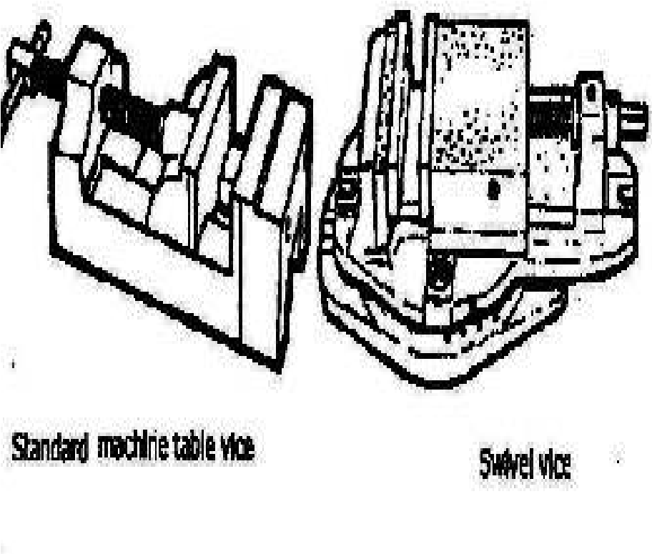

***Machine Table vice***

##### Definitions 1. Cutting Speed (v)

It’s the peripheral speed of the drill.The cutting speed depends upon the properties of the material being drilled, drill material, drill diameter, rate of speed, coolant used etc… v = Π*D*N where

D = dia of the drill in m

N = Speed of rotation in rpm

***2. Feed Rate (f)***

It’s the movement of drill along the axis (rpm)

##### 3. Depth of Cut (d)

The distance from the machined surface to the drill axis. d = D / 2

As the depth of hole increases, the chip ejection becomes more difficult and the fresh cutting fluid is not able to cutting zone. Hence for machining the lengthy hole special type of drill called ‘gun drill’ is used.

##### 4. Material Removal Rate

It’s the volume of material removed by the drill per unit time

MRR = (Π D2 / 4) * f * N mm3 / min

##### 5. Machining Time (T)

It depends upon the length (l) of the hole to be drilled , to the Speed (N) and feed (f) of the drill t = L / f N min

##### Precautions for drilling machine

* Lubrication is important to remove heat and friction.
* Machines should be cleaned after use
* Chips should be removed using brush.
* T-slots, grooves, spindles sleeves, belts, and pulley should be cleaned.
* Machines should be lightly oiled to prevent from rusting

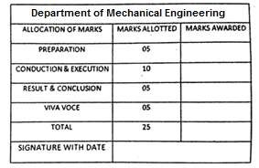

***Result:***

Thus the tools of carpentry, Welding, Sheet Metal, Plumbing and Basic machining have been studied.



**EXP: 02 MOULD FOR A SOLID Date:**

**Aim:**

To prepare a sand mold, using the given single piece pattern.

**Raw material required:**

Moulding sand, Parting sand, facing sand, baking sand, single piece solid pattern, bottom board, moulding boxes etc.

**Tools Required:**

* 1. Molding board
  2. Drag and cope boxes
  3. Molding sand
  4. Parting sand
  5. Rammer
  6. Strike-off bar
  7. Bellows
  8. Riser and sprue pins
  9. Gate cutter
  10. Vent rod
  11. Draw spike
  12. Wire Brush

**Sequence of operations:**

1. Sand preparation
2. Placing the mould flask(drag) on the moulding board/ moulding platform
3. Placing the pattern at the centre of the moulding flask
4. Ramming the drag
5. Placing runner and riser
6. Ramming the cope
7. Removal of the pattern, runner, riser 8. Gate cutting

### Procedure: Mould Making

1. First a bottom board is placed either on the molding platform or on the floor, making the surface even.
2. The drag molding flask is kept upside down on the bottom board along with the drag part of the pattern at the centre of the flask on the board.
3. Dry facing sand is sprinkled over the board and pattern to provide a non-sticky layer.
4. Freshly prepared molding sand of requisite quality is now poured into the drag and on the pattern to a thickness of 30 to 50 mm.

1. Rest of the drag flask is completely filled with the backup sand and uniformly rammed to compact the sand.
2. After the ramming is over, the excess sand in the flask is completely scraped using a flat bar to the level of the flask edges.
3. Now with a vent wire which is a wire of 1 to 2 mm diameter with a pointed end, vent holes are in the drag to the full depth of the flask as well as to the pattern to facilitate the removal of gases during casting solidification. This completes the preparation of the drag.
4. Now finished drag flask is rolled over to the bottom board exposing the pattern.
5. Using a slick, the edges of sand around the pattern is repaired
6. The cope flask on the top of the drag is located aligning again with the help of the pins of the drag box.
7. Sprue of the gating system for making the sprue passage is located at a small distance of about 50 mm from the pattern. The sprue base, runners and in-gates are also located as shown risers are also placed. Freshly prepared facing sand is poured around the pattern.



1. The moulding sand is then poured in the cope box. The sand is adequately rammed, excess sand is scraped and vent holes are made all over in the cope as in the drag.
2. The sprue and the riser are carefully withdrawn from the flask
3. Later the pouring basin is cut near the top of the sprue.
4. The cope is separated from the drag any loose sand on the cope and drag interface is blown off with the help of the bellows.
5. Now the cope and the drag pattern halves are withdrawn by using the draw spikes and rapping the pattern all around to slightly enlarge the mould cavity so that the walls are not spoiled by the withdrawing pattern.
6. The runners and gates are to be removed or to be cut in the mould carefully without spoiling the mould.
7. Any excess or loose sand is applied in the runners and mould cavity is blown away using the bellows.
8. Now the facing paste is applied all over the mould cavity and the runners which would give the finished casting a good surface finish.
9. A dry sand core is prepared using a core box. After suitable baking, it is placed in the mould cavity.
10. The cope is placed back on the drag taking care of the alignment of the two by means of the pins.
11. The mould is ready for pouring molten metal. The liquid metal is allowed to cool and become solid which is the casting desired.

**Result**:

The required mould cavity is prepared using the given Single /solid Pattern.

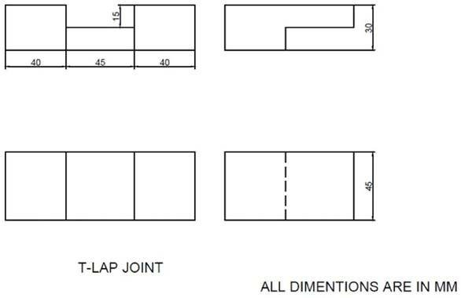

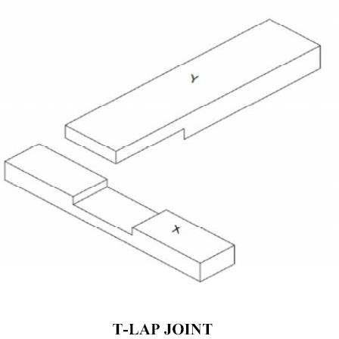

**EXP: 03 Make T joint from the given wooden pieces using carpentry tools. Date:**

**Aim: -**

Make T joint from the given wooden pieces using carpentry tools.

**Tools required: -**

* 1. Carpenter’s vice
  2. Steel Rule
  3. Try square
  4. Jack plane
  5. Scriber
  6. Cross cut saw
  7. Marking gauge
  8. Firmer chisel
  9. Mallet
  10. Wood rasp file and smooth file

**Material required: -**

Wooden pieces of size 50 x 35 x 250 mm–2 Nos.

**Sequence of operations: -**

* 1. Measuring and Marking
  2. Planning
  3. Check for squareness
  4. Removal of extra material
  5. Sawing
  6. Chiseling
  7. Finishing

#### Procedure: -

1. The given reaper is checked for dimensions.
2. They are planed with jack plane and checked for straightness.
3. The two surfaces are checked for squareness with a try square.
4. Marking gauge is set and lines are marked at 30 and 45 mm to mark the thickness and width of the model respectively.
5. The excess material is first chiseled with firmer and then planned to correct size.
6. The mating dimensions of the parts X and Y are then marked using steel rule and marking gauge.
7. Using the crosscut saw, the portions to be removed are cut in both the pieces, followed by chiseling.
8. The ends of both the parts are chiseled to the exact lengths.
9. The fine finishing is given to the parts, if required so that, proper fitting is obtained.

1. The parts are fitted to obtain a slightly tight joint.

#### Safety precautions: -

1. Loose cloths are to be avoided.
2. Tools to be placed at their proper placed.
3. Hands should not be placed in front of sharp edged tools.
4. Use only sharp tools.
5. Care should be taken, when thumb is used as a guide in cross cutting and ripping.
6. Handle while chiseling, sawing and planning with care.



#### Result: -

T- lap joint is made as per the required dimensions.



36

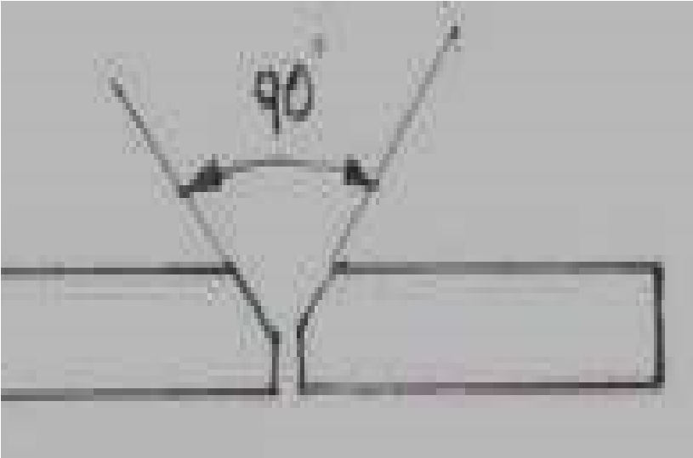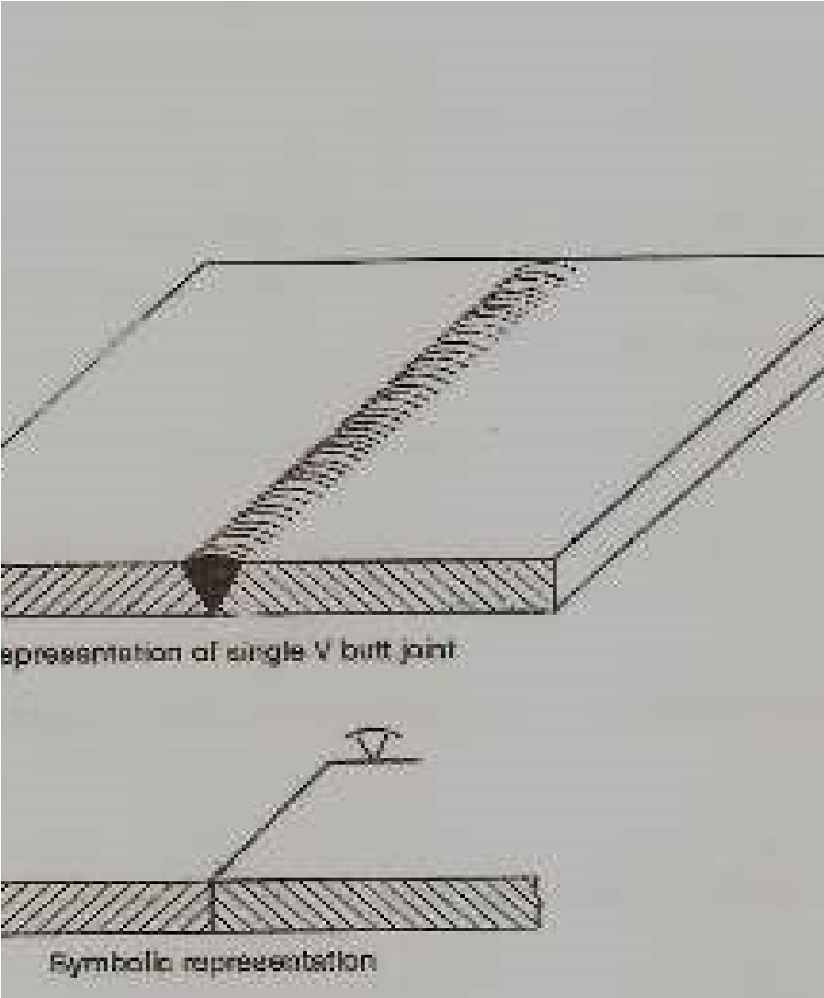

**EXP: 04 Make a butt joint using arc welding equipment. Date:**



**Aim**: Preparation of butt joint as shown in figure using shielded metal arc welding process.

**Material required**:

2m.s flat pieces of given size.

***Tools required****:*

1. welding transformer,
2. connecting cables,
3. electrode holder,
4. ground clamp,
5. electrodes,
6. hipping hammer, 7. Welding shield etc.

***Procedure:***

1. The given metallic pieces filled to the desired size.
2. On both pieces beveled in order to have V groove.
3. The metallic pieces are thoroughly cleaned from rust grease, oil, etc.
4. The metallic pieces are connected to terminals of Trans former.
5. Select electrode dia based on thickness of work piece and hold it on the electrode holder. Select suitable range of current for selected dia.
6. Switch on the power supply and initiates the arc by either striking arc method or touch and drag method.
7. Take welding to be done before full welding.
8. In full welding process after completion one part before going to second part. Slag is removed from the weld bed. With the metal wire brush or chipping hammer.
9. Then the above process will be repeated until to fill the groove with weld bed or weld metal.

**Precautions:**

1. Use goggles, gloves in order to protect the human body.
2. Maintain the constant arc length.

**Result**:

**Thus** butt joint is prepared as shown in figure by using arc-welding process.

38

All dimensions are in mm

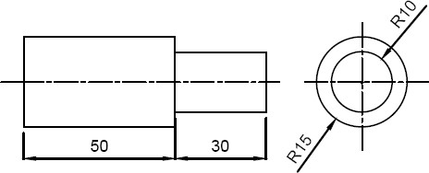

**EXP: 05 FACING AND TURNING OPERATION Date:**



***Aim:***

To make Plain/Step turning on a given MS rod by using Lathe

***Tools Required:***

* + - 1. Single Point Cutting Tool
      2. Scriber
      3. Steel Rule
      4. Outside Caliper
      5. Chuck Key
      6. Tool Post Spanner ***Procedure:***
      7. The given work piece is checked for its dimensions
      8. The work piece is held in the chuck. Chuck key is used to tighten the job firmly, centering of work piece is ensured
      9. The single point cutting tool is held in the tool post and tighten the nuts using spanner
      10. Facing is done with cutting tool moving from the centre of work piece towards outside. It is done until the required length of the required length of the work piece is obtained
      11. Turning is done to reduce the diameter of the job. Sufficient depth of cut is given and it is done until the required diameter of the job is obtained
      12. Finally the dimension of the work piece are again checked **Viva voce:**

1.What is the function of lathe machine?

2.Name the only five parts of lathe machine?

3.What is the use of chuck?

* 1. Name the types of chuck?
  2. Name the operation which can be performed by lathe machine?

***Result:***

Thus the required size and shape of the given work piece is obtained

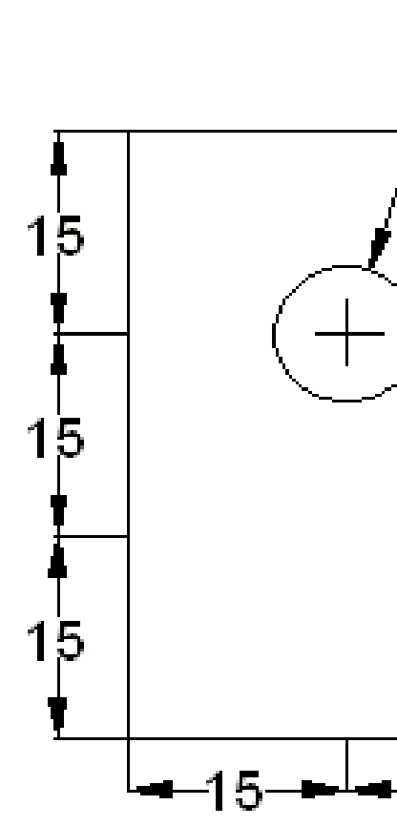

40

All di

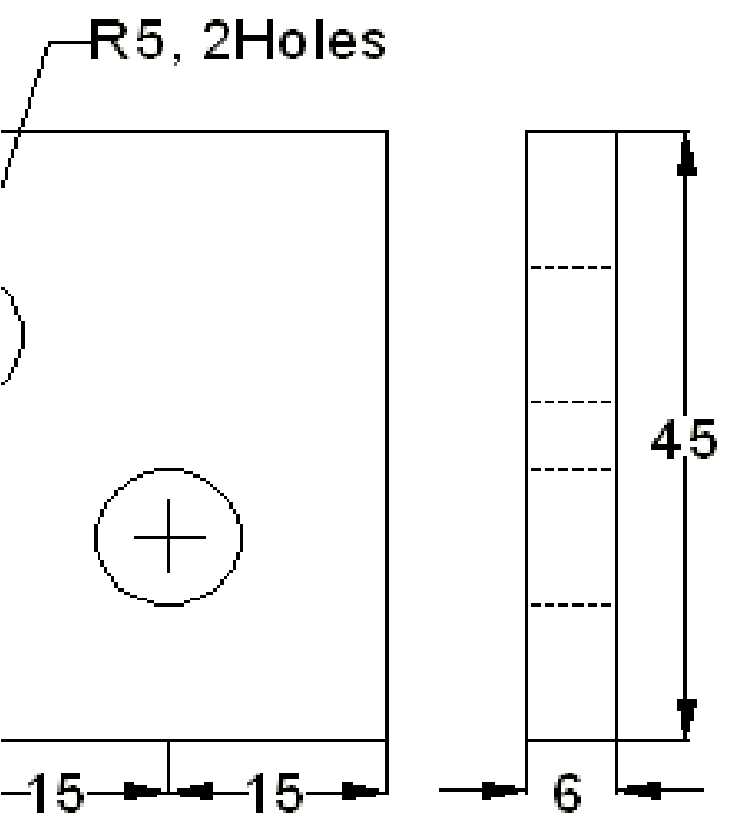

mensions are in mm

**EXP: 06**  **DRILLING**   **Date:**



***Aim:***

To make drilling and tapping operation on a given MS plate by using drilling machine ***Tools Required:***

* + - * 1. Steel rule
        2. Try Square
        3. Scriber
        4. Dot Punch
        5. Drill bit
        6. Tap set with die holder
        7. Flat Rough file ***Procedure:***
        8. The given work piece is checked for its dimensions using steel rule
        9. Then the work piece is clamped in a vice and any two surface are filed to get right angle using flat rough file
        10. Chalk is applied uniformly on the surface of the work piece
        11. Wit the help of venire height gauge, Surface plate, Angle Plate, Steel Rule and Scriber the given dimensions are marked
        12. The mid point of the required holes is punched by using dot punch
        13. The punched dotes are drilled by using drilling machine
        14. After drilling the holes are tapped using tap set
        15. Finally the dimensions are again checked **Viva voce:**

1.What is the use of drilling?

2.What is the uses of tapping?

3.Differentiate between tapping and drilling?

4.Which material is used?

5. What is the dimension of the plate?

***Result:***

Thus the given work piece is drilled and tapped to the required dimensions

**K.S.R. COLLEGE OF ENGINEERING : TIRUCHENGODE - 637 215**

**(Autonomous)**

**DEPARTMENT OF MECHANICAL ENIGNEERING**

##### (REGULATION 2020)

**Vision of the Institution**

|  |
| --- |
| **IV** We envision to achieve status as an excellent educational institution in the global knowledge hub, making self-learners, experts, ethical and responsible engineers, technologists, scientists, managers, administrators and entrepreneurs who will significantly contribute to research and environment friendly sustainable growth of the nation and the world. |
| **Mission of the Institution** |
| **IM 1** To inculcate in the students self-learning abilities that enable them to become competitive and considerate engineers, technologists, scientists, managers, administrators and entrepreneurs by diligently imparting the best of education, nurturing environmental and social needs.  **IM 2** To foster and maintain mutually beneficial partnership with global industries and Institutions through knowledge sharing, collaborative research and innovation. |
| **Vision of the Department / Programme: (Mechanical Engineering)** |
| **DV** To be a centre of excellence in the field of Mechanical Engineering for providing its students and faculty with opportunities for excel in education and targeted research themes in emerging areas. |
| **Mission of the Department / Programme: (Mechanical Engineering)** |
| **DM 1** To excel in academic and research activities that meet the industrial and social needs.  **DM 2** To develop competent, innovative and ethical mechanical Engineers. |
| **Programme Educational Objectives (PEOs) : (Mechanical Engineering)** |
| **The graduates of the programme will be able to**  **PEO 1 Successful career:** Identify, design and apply the technical skills to solve mechanical engineering problems for enhancing the quality of life.    **PEO 2 Lifelong Learning:** Apply the modern tools and techniques to face the challenges in mechanical and related engineering areas.    **PEO 3 Service to society:** Understand the responsibility, communicate and implement innovative ideas in multidisciplinary teams ethically for uplifting the society. |